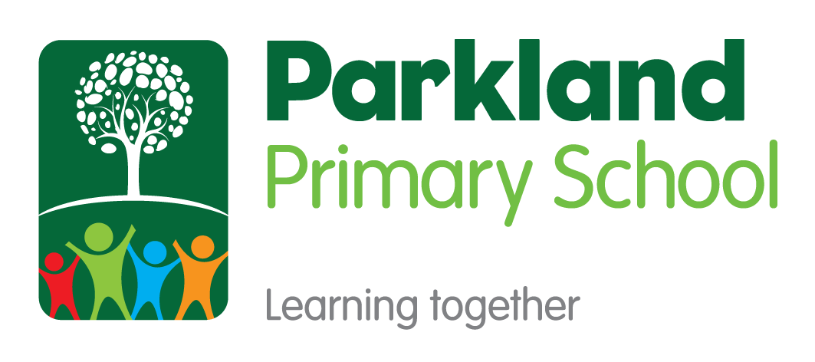

HISTORY
Subject Policy

Subject Leader(s): James Scarborough
Robert Rowell
Last Reviewed: May 2022

Rationale
This policy outlines the intent, implementation and intended impact for the teaching, leadership and assessment of history at Parkland Primary School. The school’s policy for history follows the 2014 National Curriculum Framework and the Early Years Foundation Stage Framework.

Our Mission
At Parkland Primary School, we believe that every child in our school community should have Limitless Learning opportunities. We all have the ability to succeed and our school works hard to ensure that our pupils can Discover their Potential.
Our Values: Grow, Believe, Achieve, Succeed

Intent
At Parkland Primary School we have worked together to create a shared language for learning (Appendix 1). Underpinning this and all curriculum design is our whole school definition of learning:
‘Learning is the process of building on and strengthening the connections in your brain.’

A high-quality history education will help pupils gain a coherent knowledge and understanding of Britain’s past and that of the wider world. It should inspire pupils’ curiosity to know more about the past. Teaching should equip pupils to ask perceptive questions, think critically, weigh evidence, sift arguments, and develop perspective and judgement. History helps pupils to understand the complexity of people’s lives, the process of change, the diversity of societies and relationships between different groups, as well as their own identity and the challenges of their time.
Aims of history knowledge-led curriculum
To ensure that all pupils:
- know and understand the history of these islands as a coherent, chronological narrative, from the earliest times to the present day: how people’s lives have shaped this nation and how Britain has influenced and been influenced by the wider world
- know and understand significant aspects of the history of the wider world: the nature of ancient civilisations; the expansion and dissolution of empires; characteristic features of past non-European societies; achievements and follies of mankind
- gain and deploy a historically grounded understanding of abstract terms such as ‘empire’, ‘civilisation’, ‘parliament’ and ‘peasantry’
- understand historical concepts such as continuity and change, cause and consequence, similarity, difference and significance, and use them to make connections, draw contrasts, analyse trends, frame historically-valid questions and create their own structured accounts, including written narratives and analyses
- understand the methods of historical enquiry, including how evidence is used rigorously to make historical claims, and discern how and why contrasting arguments and interpretations of the past have been constructed
- gain historical perspective by placing their growing knowledge into different contexts, understanding the connections between local, regional, national and international history; between cultural, economic, military, political, religious and social history; and between short- and long-term timescales.

At Parkland Primary School, teachers work collaboratively using subject progression maps and knowledge mapping to coherently plan and sequence learning journeys designed to allow our pupils to gain cumulatively sufficient knowledge to ensure they are ready for the next stage of their education.

Curriculum Drivers
At Parkland Primary School, through the delivery of a high-quality knowledge led history curriculum we aspire for our pupils to be…

Implementation
How history is planned and taught:
Teachers work collaboratively to plan history using the learning journey planning format (Appendix 2). history is planned using progression maps and knowledge mapping to ensure teaching is designed to help learners to remember, in the long term, the content they have been taught and to integrate new knowledge into larger concepts.
For the wider curriculum we block learning and re-visit practice over time through a spaced practice approach (Learning Scientists, 2016) as research suggests this will lead to better long-term retention of knowledge. Retrieval practice is a fundamental part of our history curriculum as it is proven to strengthen memory and make it easier to retrieve the information later (Rosenshine, 2012). Opportunities for retrieval practise occur in two places in the curriculum:
- Daily review to activate prior learning forms the start of most lessons.
- Retrieval practice of non-negotiable taught knowledge will happen on three separate spaced occasions away from the point of teaching the topic. This should support children in securing long-term knowledge acquisition.

Phase and subject leaders are responsible for ensuring that the taught curriculum in each phase mirrors the intended progression of knowledge and skills mapped out for each Phase in the progression document. Therefore, ensuring previous content supports subsequent learning and pupils are equipped with the knowledge necessary for the next stage in their education and that the full content of National Curriculum is taught before children leave Parkland Primary School.

EYFS:
The EYFS framework is structured very differently to the national curriculum as it is organised across seven areas of learning rather than subject areas. The skills taught across EYFS do feed into our history curriculum. The most relevant early years outcomes for history are taken from the area of learning entitled, ‘Understanding the World’.

KS1 / KS2

In planning for progression, teachers are often introducing pupils at KS1 to historical periods that they will study more fully at key stages 2 and 3. Our history progression map is used by teachers to ensure that there is progression in knowledge and skills through the school. These areas of knowledge and skills are segmented into the following strands: Chronological understanding, events, people and changes in the past, historical vocabulary, historical enquiry, and historical interpretation.

History topics will be taught in blocks to provide deep learning opportunities. Where appropriate, teachers should combine overview and depth studies to help pupils understand both the long arc of development and the complexity of specific aspects of the content. A humanities unit will be taught once per half-term (whether that be history or geography and will vary per year group; dependent on the objectives to be covered). Each block will be roughly two weeks in length and follow the structure planning outline below:

Stage | Key features of the teaching and learning | Assessment
1-Macro Level | - Assess relevant prior learning  - Big Picture Introduction  - Chronology and Coherence: Always start by referring to the new unit on an overview timeline: Where does this unit fit into what they have learnt before? Do they have a sense of scale?  - Key concept vocabulary shared and taught in context e.g. civilisation, empire, parliament, peasantry.  - Teach the knowledge required to gain a good broad understanding of the:  - Period – when in history this was?  - Context – what significant things were happening at the time to cause of create this period of history  - Links – how did this period links to what went before or after? | Prior knowledge  Daily review  Use of knowledge organiser to quiz throughout
2 - Micro level | Go deeper into an enquiry-based question or area of the unit.  Choose a relevant question or strand and outcome with which you can focus on a specific element of the unit: link to ‘Events People and Changes in the Past’ strand of progression document.  In Key Stage 2, children may write an extended response at the end of the week.  For example:  Local History Study: What was the impact of World War One on the local area?  UKS2: What caused the start of World War One?  UKS2: How was The Battle of Britain a significant turning point in British history?  LKS2: What were the similarities and differences between the different periods of the Stone Age?  LKS2: How far did the Romans change the life of the Britons during their period of occupation?  Source work case study (KS2 only at least one per year)  UKS2: What do these sources tell us about the conditions for soldiers in the trenches during WWI?  LKS2: What can we tell about Roman life from a study of this villa/fort? Case study of places such as Caerwent, Fishborne, Lullingstone | Daily review  Use of knowledge organiser to quiz throughout  Formative assessment against progression map criteria for the extended answer to the enquiry-based question  Formative knowledge quiz at the end of the block

Effective teaching of history:
Parkland Primary School prides itself on being a research informed school. Following staff training on Rosenshine’s Principles in Action (Sherrington and Caviglioli, 2019) school teachers are expected to actively present material and structure lessons using the ten principles of instruction below. These principles not only facilitate the memorising of information, but allow pupils to understand it as an integrated whole, and to recognise the relationships between the parts. This does not mean that every lesson needs to follow the exact structure or sequence and this is not intended to be used as checklist for each lesson; these elements can occur at different points in a lesson, or over a sequence of lessons, and can be integrated in different ways and at different times.
Principles of Instruction:
- Daily Review – lessons begin with a short review of previous learning to re-activate recently acquired knowledge.
- Present new material using small steps – recognise the limitations of the working memory by breaking down concepts and procedures into small steps.
- Ask questions – teachers need to ask large numbers of questions to check for understanding
- Provide models – a central feature of giving good explanations. These may include concrete models to aid abstract concepts, worked narrative examples modelling a process
- Guide student practice – give time to guide student practice supported by modelling, corrective feedback and re-teaching where gaps remain.
- Check for student understanding – teachers use their questioning to ascertain from as many children as possible what they have understood? A range of questioning strategies below can be used to do this (see below).
- Obtain a high success rate – teachers need to engineer a high success rate (around 80%) where children are reinforcing error-free, secure learning, improving fluency and confidence providing a platform for independent practice. However, it is still important pupils are challenged here (a success rate a 90%+ is too high).
- Provide scaffolds for difficult tasks – temporary aids may be required to support children in developing a level of independence but are withdrawn at the right point so that pupils don’t become reliant upon them.
- Independent Practice – here teachers need to construct learning so that students are able to do challenging things by themselves without help. It is important that the material that students practise is the same as during guided practise for appropriate levels of success to be secured
- Weekly and Monthly Review – to ensure that previously learned material is not forgotten and break the forgetting curve. A variety of retrieval techniques can be used to do this.
Questioning Strategies used at Parkland Primary School:
- How do you know? Justify Why?
- What’s the same? What’s different?
- Mathematical Superheros: Captain conjecture, Ace organiser, Canine the Convincer, The Classifier, The Specialiser, The Visualiser and Excellent Expressor
- Think – Pair – Share
- Cold call (no hands up)
- No opt out (bounce back if a child isn’t able to answer initially)
- Probing questions (staying with a child to probe deeper to check understanding)
- Say it again better (ask children to rephrase answers a second time to build a deeper, high quality answer)
- Agree, Disagree, Add your own… (to structure class discussion around a question)
- Whole class response: choral, whiteboard, ABCD, thumbs up + down for true or false
Inclusion and Equal Opportunities (challenge for all):
In line with our mission statement, we believe every child will have equal opportunity to achieve their full potential and access an ambitious and coherent curriculum that leads to deep learning and an understanding of a sustainable world. Regardless of race, gender, cultural background, ability or Special Educational Needs or Disability.
If a child has a special educational need of disability, we will do our very best to ensure we meet that child’s individual needs when accessing the history curriculum. We comply with the requirements set out in the SEND Code of Practice. If a teacher has concerns about the progress of a child, then they will liaise with the in school SENDCO to arrange appropriate assessment of need and set up personal provision through initially writing a Personalised Provision Plan. In some cases, where the demands of the curriculum may be too much, this may involve the use of PIVATS targets to track small step progress for this child or differentiation within the classroom environment to meet the needs of that child.
Impact
Assessing Progress
Formative Assessment:
Pupils’ progress will be assessed using regular formative assessment in lessons through strategies such as questioning, regular retrieval practice, quizzing, independent learning tasks and assessment of work in books and feedback.
Each learning journey block will be assessed formatively through the use of a knowledge-based quiz and/or a high-quality independent skills application outcome e.g. musical composition or piece of artwork. Teachers will use this assessment to provide further feedback or re-teach concepts where necessary to close gaps and ensure pupils have mastered the curriculum content at that point.
Summative Assessment:
Assessing long-term learning:
The identified non-negotiable knowledge for history, for each learning journey will then be re-tested through a knowledge-based retrieval task. This will happen on three separate spaced occasions to secure long-term knowledge acquisition and be used for more summative purposes.
Skills will be sequentially re-visited and built upon due to the coherently planned and sequenced progression mapping across the school.
Tracking Pupil Progress:
- Pupil progress within the subject will be tracked through the use of low threat knowledge-based retrieval tasks at the end of each unit taught.
- Scores from these low threat knowledge-based retrieval tasks are to be tracked in the back of the Learning Journey book .
- These retrieval tasks will be revisited a month after the unit is completed and again a term after the unit is completed to assess retention of knowledge taught.
Individual progress is reported to parents through two termly Parents’ Evenings and an end of year report.

References:
Rosenshine. B. (2012) Principles of Instruction: Research-Based Strategies That All Teachers Should Know. American Educator, 36 (1) p12-19.
Sherrington, T. and Caviglioli, O. (2019) Rosenshine's Principles In Action.
The Learning Scientists (2016). [Posters and Blogs]. Available at: https://www.learningscientists.org [Accessed 6 Sep. 2019].
Bibliography:
Christodoulou, D. (2016) Making Good Progress: The future of Assessment for Learning

