**Parkland Primary School Curriculum Newsletter**

Year 5 Term: Autumn 2

[This Photo](https://en.wikipedia.org/wiki/Ultraviolet_astronomy) by Unknown Author is licensed under [CC BY-SA](https://creativecommons.org/licenses/by-sa/3.0/)

**Maths**

This term Year 5 are learning about multiplication, division and fractions. They will learn how to apply their knowledge with factors, common factors, prime numbers, square numbers, cube numbers as well as learning to multiply and divide by 10, 100 and 1,000. In fractions they will learn equivalent fractions for unit and non-unit factions, converting improper fractions and mixed numbers as well as how to compare these.

**Reading**

This term in reading, Year 5 are learning about WW1. They will be focusing on word meaning, working out how content contributes to meaning as a whole and how meaning is enhanced through word and phrase choices. In addition to this, we will be revisiting retrieval and inference skills as well as making comparisons between types of texts throughout the half term.

**English**

In English this term, Year 5 will explore war poetry and focus on the poem ‘In Flander’s Field’ by John McRae. Further in the term, Year 5 will be discussing if Great Britain should have fought in WW1. They will present ideas both for and against. We shall end the English learning journey by learning how to write an informal letter, where we will take on the role as a British solider in the trenches during the Christmas Truce 1914.

**Autumn 2 Topic**

**Fallen Fields**

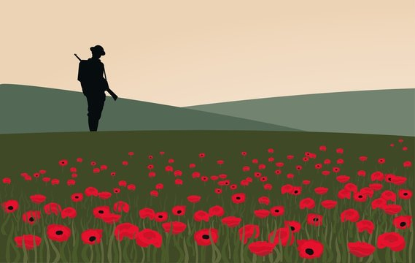

**PSHE and Wellbeing**

We complete our PSHE topic Changing Feelings. Then we move into a new topic called protective behaviours, which focus on how we can keep ourselves safe in a variety of situations.

We also continue to explore mindfulness techniques to help us relax and focus on our learning.

**Wider Curriculum Learning Journeys**

Our wider curriculum this half term is focused on learning more about the First World War, and the significance it had on the development on the UK. Obviously much of our learning will be History focused, exploring why the war actually started, how the war changed lives and the conditions men fought in. We will be focusing on European Geography and exploring the locations of countries involved in the First World War using maps and atlases. We will also be exploring the work of War Artist Paul Nash in Art lessons.

**Reminders**

**Water Bottle**

Please ensure your child has a **re-useable** water bottle with them in school to keep them healthy and hydrated.

**PE Days**

**Please remember to send your child into school in suitable, warm PE kit on their PE days below.**

## **5NA – Wednesdays and Thursdays**

## **5AN – Wednesdays and Thursdays**

## **5RR – Tuesdays and Fridays**

**Key Dates this Term**

|  |  |
| --- | --- |
| Date | Event |
| Tuesday 1st November 2022 | **EYFS Disco:** 3.15pm – 4.15pm  **Y3/4 Disco**: 4.30pm – 5.30pm |
| Wednesday 2nd November 2022 | **Y1/2 Disco:** 3.15pm -4.15pm  **Y5/6 Disco:** 4.30pm – 5.30pm |
| Friday 11th November 2022 | Remembrance Day |
| Tuesday 15th November 2022 | PTA Harvest Meal 5pm – 6.30pm |
| Friday 18th November 2022 | Children In Need/Anti-Bullying Week |
| Friday 18th November 2022 | Flu Vaccination (Foundation to Year 6) |
| Monday 21st November 2022 | **SCHOOL CLOSED – PD Day** |
| Thursday 1st December 2022 | Christmas Decoration Day  **Pre-School:** 9.00am – 10.15am  **EYFS & Y1/2:** 9.00am – 10.15am |
| Friday 2nd December 2022 | Christmas Decoration Day  **Y3/4/5/6:** 9.00am – 10.15am |
| Thursday 15th December 2022 | Christmas Dinner Day |
| Monday 19th December 2022 | **SCHOOL CLOSED FOR CHRISTMAS BREAK** |

**Noticeboard**

Term: Autumn 2