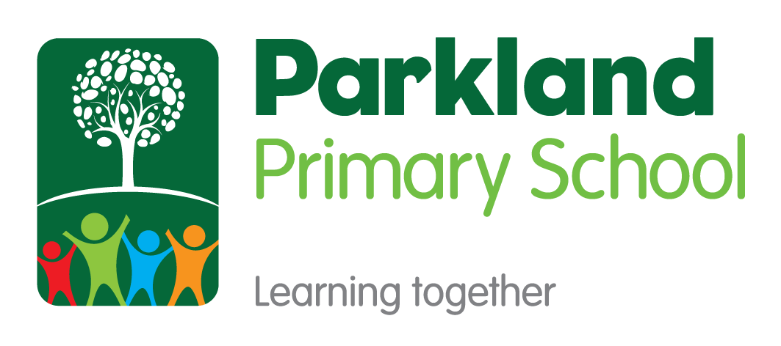

Science
Subject Policy

Subject Leader(s): Rachael Durham and Hanna West
Last Reviewed: November 2021

Rationale
This policy outlines the intent, implementation and intended impact for the teaching, leadership and assessment of Science at Parkland Primary School. The school’s policy for Science follows the 2014 National Curriculum Framework and the Early Years Foundation Stage Framework.

Our Mission
At Parkland Primary School, we believe that every child in our school community should have Limitless Learning opportunities. We all have the ability to succeed and our school works hard to ensure that our pupils can Discover their Potential.
Our Values: Grow, Believe, Achieve, Succeed

Intent
At Parkland Primary School we have worked together to create a shared language for learning (Appendix 1). Underpinning this and all curriculum design is our whole school definition of learning:
‘Learning is the process of building on and strengthening the connections in your brain.’

A high quality Science curriculum provides the foundations for understanding the world through the specific disciplines of biology, chemistry and physics. Science has changed our lives and is vital to the world’s future prosperity, and all pupils should be taught essential aspects of the knowledge, methods, processes and uses of science. Through building up a body of key foundational knowledge and concepts, pupils should be encouraged to recognise the power of rational explanation and develop a sense of excitement and curiosity about natural phenomena. They should be encouraged to understand how science can be used to explain what is occurring, predict how things will behave, and analyse causes.

Aims of Science knowledge-led curriculum:
- pupils develop scientific knowledge and conceptual understanding through the specific disciplines of biology, chemistry and physics
- pupils develop understanding of the nature, processes and methods of science through different types of science enquiries that help them to answer scientific questions about the world around them
- pupils are equipped with the scientific knowledge required to understand the uses and implications of science, today and for the future
At Parkland Primary School, teachers work collaboratively using subject progression maps and knowledge mapping to coherently plan and sequence learning journeys designed to allow our pupils to gain cumulatively sufficient knowledge to ensure they are ready for the next stage of their education.

Curriculum Drivers
At Parkland Primary School, through the delivery of a high-quality knowledge led Science curriculum we aspire for our pupils to be…

Implementation
How Science is planned and taught:
Teachers work collaboratively to plan Science using the learning journey planning format (Appendix 2). Science is planned using progression maps and knowledge mapping to ensure teaching is designed to help learners to remember, in the long term, the content they have been taught and to integrate new knowledge into larger concepts.
For the wider curriculum we block learning and re-visit practice over time through a spaced practise approach (Learning Scientists, 2016) as research suggests this will lead to better long-term retention of knowledge. Retrieval practice is a fundamental part of our Science curriculum as it is proven to strengthen memory and make it easier to retrieve the information later (Rosenshine, 2012). Opportunities for retrieval practise occur in two places in the curriculum:
- Daily review to activate prior learning forms the start of most lessons.
- Retrieval practice of non-negotiable taught knowledge will happen on three separate spaced occasions away from the point of teaching the topic. This should support children in securing long-term knowledge acquisition.
EYFS:
The EYFS Framework focuses the learning and development of children in the foundation years through seven areas of learning. The knowledge and skills taught in EYFS feed into the science curriculum but are not taught as subject specific. The most relevant early years outcomes for science are taken from the area of learning entitled, ‘Understanding the World’.

The knowledge and skills needed to achieve these outcomes are taught mostly through children playing and exploring during continuous provision times in the day. Teachers deliberately plan enhanced activities which give opportunities for children to learn through their own discovery. Some elements of Understanding The World are taught through teacher-led lessons which link to half-termly topics such as; All About Me and Where I live, Farming and Minibeasts.

KS1/ KS2:
The Science curriculum is planned to build on previous learning of knowledge and skills, before developing new learning. Using the subject progression documents for both Science knowledge objectives and Working Scientifically skills, teachers plan Science Learning Journeys. Teachers plan a Science Learning Journey to include a pre-assessment or quiz of the children’s prior knowledge, which is then used to support the route of the journey. Learning Journeys are taught in blocks of lessons and therefore Science is timetabled differently in each year group. Teaching Science as a block of lessons throughout a week or two, allows the children to master and deepen their scientific knowledge as they are encouraged to think scientifically and develop their skills, alongside mastering new knowledge. This is supported by carrying out low stake quizzes throughout the learning journeys and the use of knowledge organisers to clarify the knowledge needed to meet the learning objectives.
Effective teaching of Science:
Parkland Primary School prides itself on being a research informed school. Following staff training on Rosenshine’s Principles in Action (Sherrington and Caviglioli, 2019) teachers are expected to actively present material and structure lessons using the ten principles of instruction below. These principles not only facilitate the memorising of information but allow pupils to understand it as an integrated whole, and to recognise the relationships between the parts. This does not mean that every lesson needs to follow the exact structure or sequence and this is not intended to be used as checklist for each lesson; these elements can occur at different points in a lesson, or over a sequence of lessons, and can be integrated in different ways and at different times.
Principles of Instruction:
- Daily Review – lessons begin with a short review of previous learning to re-activate recently acquired knowledge.
- Present new material using small steps – recognise the limitations of the working memory by breaking down concepts and procedures into small steps.
- Ask questions – teachers need to ask large numbers of questions to check for understanding
- Provide models – a central feature of giving good explanations. These may include concrete models to aid abstract concepts, worked narrative examples modelling a process
- Guide student practice – give time to guide student practice supported by modelling, corrective feedback and re-teaching where gaps remain.
- Check for student understanding – teachers use their questioning to ascertain from as many children as possible what they have understood? A range of questioning strategies below can be used to do this (see below).
- Obtain a high success rate – teachers need to engineer a high success rate (around 80%) where children are reinforcing error-free, secure learning, improving fluency and confidence providing a platform for independent practice. However, it is still important pupils are challenged here (a success rate a 90%+ is too high).
- Provide scaffolds for difficult tasks – temporary aids may be required to support children in developing a level of independence but are withdrawn at the right point so that pupils don’t become reliant upon them.
- Independent Practice – here teachers need to construct learning so that students are able to do challenging things by themselves without help. It is important that the material that students practise is the same as during guided practise for appropriate levels of success to be secured
- Weekly and Monthly Review – to ensure that previously learned material is not forgotten and break the forgetting curve. A variety of retrieval techniques can be used to do this.
Questioning Strategies used at Parkland Primary School:
- How do you know? Justify why?
- What if….?
- Which is the odd one out?
- What’s the same? What’s different?
- Mathematical Superheroes: Captain Conjecture, Ace Organiser, Canine the Convincer, The Classifier, The Specialiser, The Visualiser and Excellent Expressor
- Think – Pair – Share
- Cold call (no hands up)
- No opt out (bounce back if a child cannot answer initially)
- Probing questions (staying with a child to probe deeper to check understanding)
- Say it again better (ask children to rephrase answers a second time to build a deeper, high quality answer)
- Agree, Disagree, Add your own… (to structure class discussion around a question)
- Whole class response: choral, whiteboard, ABCD, thumbs up + down for true or false
Inclusion and Equal Opportunities (challenge for all):
In line with our mission statement, we believe every child will have equal opportunity to achieve their full potential and access an ambitious and coherent curriculum that leads to deep learning and an understanding of a sustainable world. Regardless of race, gender, cultural background, ability or Special Educational Needs or Disability.
If a child has a special educational need of disability, we will do our very best to ensure we meet that child’s individual needs when accessing the Science curriculum. We comply with the requirements set out in the SEND Code of Practice. If a teacher has concerns about the progress of a child, then they will liaise with the in school SENDCO to arrange appropriate assessment of need and set up personal provision through initially writing a Personalised Provision Plan. In some cases, where the demands of the curriculum may be too much, this may involve the use of PIVATS targets to track small step progress for this child or differentiation within the classroom environment to meet the needs of that child.
Impact
Assessing Progress
Formative Assessment:
Pupils’ progress will be assessed using regular formative assessment in lessons through strategies such as questioning, regular retrieval practice, quizzing, independent learning tasks and assessment of work in books and feedback.
Each learning journey block will be assessed formatively using a knowledge-based quiz and/or a high-quality independent skills application outcome e.g. written report or conclusion. Teachers will use this assessment to provide further feedback or re-teach concepts where necessary to close gaps and ensure pupils have mastered the curriculum content at that point.
Assessing long-term learning:
The identified non-negotiable knowledge for Science, for each learning journey will then be re-tested through a knowledge-based retrieval task. This will happen on three separate spaced occasions to secure long-term knowledge acquisition and be used for more summative purposes.
Skills will be sequentially re-visited and built upon due to the coherently planned and sequenced progression mapping across the school.
Tracking Pupil Progress:
In Science, pre and post assessments are used to assess the learning of each individual child. This may look different for each year group, depending on the topic that they are studying and what has been taught in previous year groups. Individual progress is reported to parents through two termly Parents’ Evenings and an end of year report.
References:
Rosenshine. B. (2012) Principles of Instruction: Research-Based Strategies That All Teachers Should Know. American Educator, 36 (1) p12-19.
Sherrington, T. and Caviglioli, O. (2019) Rosenshine's Principles In Action.
The Learning Scientists (2016). [Posters and Blogs]. Available at: https://www.learningscientists.org [Accessed 6 Sep. 2019].
Bibliography:
Chistodoulou, D. (2016) Making Good Progress: The future of Assessment for Learning

